PROFILE/ CATHERINE “CAT” ZIDELL

DATE OF BIRTH: Well, I actually hit the big 50 this year!!!!!
BORN/GREW UP IN: Born in Chicago but shortly after moved to Dallas, Texas
CURRENT RESIDENCE: Dallas
MARITAL STATUS: Married to a wonderful man named Jeff for 11 years now.
HEIGHT: 5’ 7 ½”
WEIGHT: 160 off season/ 144 at contest
CURRENT OCCUPATION: Retired flight attendant after almost 25 years! I am now personal trainer.
FAVORITE HOBBY: My first passion was riding and showing horses and then I found fitness! Now it is a tie.
FAVORITE FOOD: Pancakes!!
FAVORITE MUSIC: Rock!!
BEST BODYPART: My legs. Do you remember the song, “She’s got legs”? I love that song. See above.
YEARS TRAINING: 11 years now.
EMAIL: nshape@swbell.net
WEBSITE: http://www.catherinezidell.com
HOW DID YOU GET INTERESTED IN BODYBUILDING/WORKING OUT?
I have always been active when growing up and worked out to stay fit and slim, they had “weight check” every week at the airlines. We would wear hot pants as a uniform!!! I was working out one day and a group of men asked if I wanted to lift weights with them. I started meeting with them everyday at noon and was hooked the moment I started.
WHAT WAS YOUR FIRST SHOW LIKE I continued to work out for about a year and a half. Packing all my food and finding a gym in every city that we had a layover in and in 1996 I decided to do my first show. I was so nervous about remembering my routine and my posing. I just practiced and practiced! Unfortunately, my father became very ill and was in ICU in Honolulu Hawaii. With only 4 weeks until the show, I flew out there and got an apartment and stayed for almost 3 weeks. I continued to train and practice in between the ICU visits. I think the contest preparation was the only thing that kept me from losing control. My father recovered somewhat and I went home and my husband and trainer were shocked. They couldn’t believe how in condition I was. I went on to the competition and won second in the novice heavyweight division. I loved how friendly all the competitors were and how everyone was willing to help each other.
WHAT DO YOU LIKE AND DISLIKE ABOUT COMPETING? Like I said, I love how everyone is so friendly at each and every show. I have made a lot of new friends. I think the thing about competing I don’t like is the constant worry about how well I am going to “peak” and the water restriction.
WHAT ARE YOUR FUTURE GOALS IN THIS INDUSTRY? My goal for 2005 is to come back to the Masters, Teen and Collegiate Nationals and win the 50 and over tall class in figure since I won the over 35 Tall Figure class last year at 49! I also want to show other women that it is never too late to get in shape and set goals and compete. I didn’t enter my first show until I was 41.
WHAT DO YOU SEE YOURSELF DOING IN 10 YEARS? I hope that I will be still competing and winning the over 60 class.

PLEASE TELL US SOMETHING SPECIAL ABOUT YOU THAT MOST PEOPLE WOULDN’T KNOW : I

I want to thank all the wonderful trainers, family and friends for their positive support all these years. I especially want to thank my loving husband for his continued reinforcement that I am never too old to continue to pursue this endeavor.
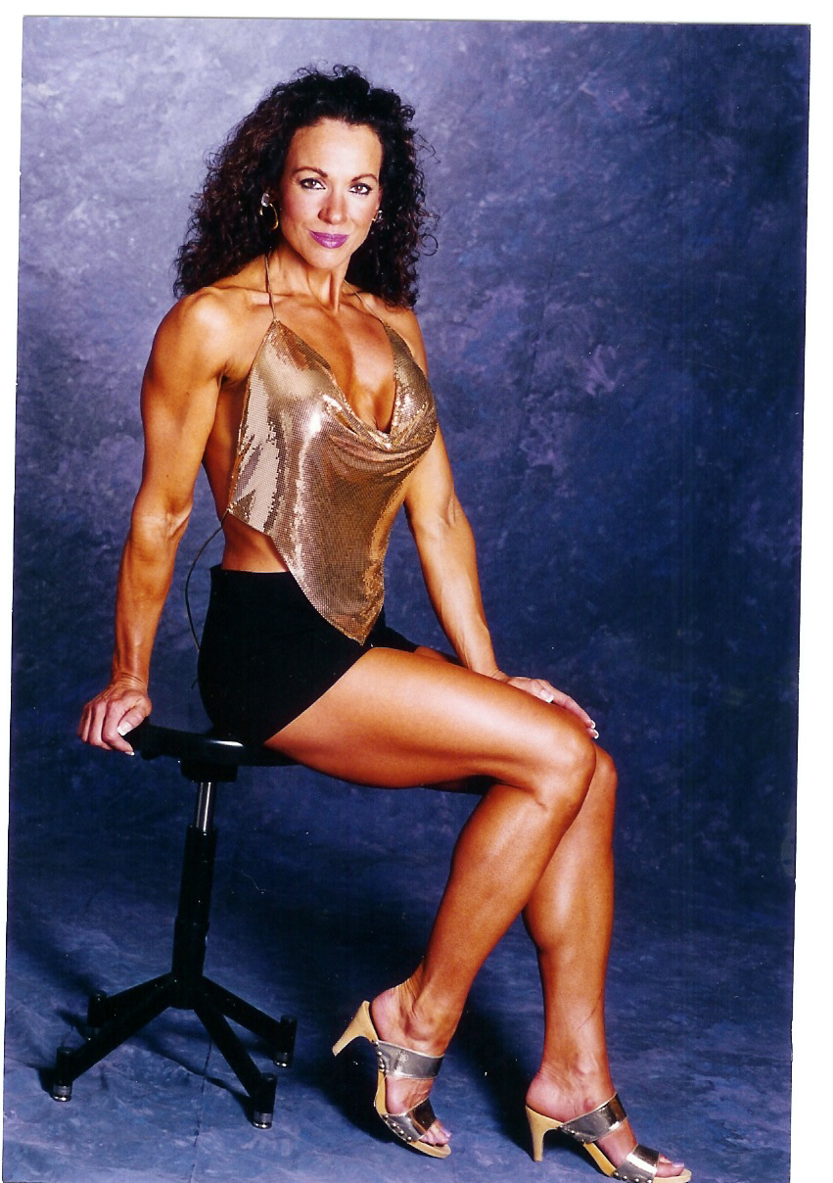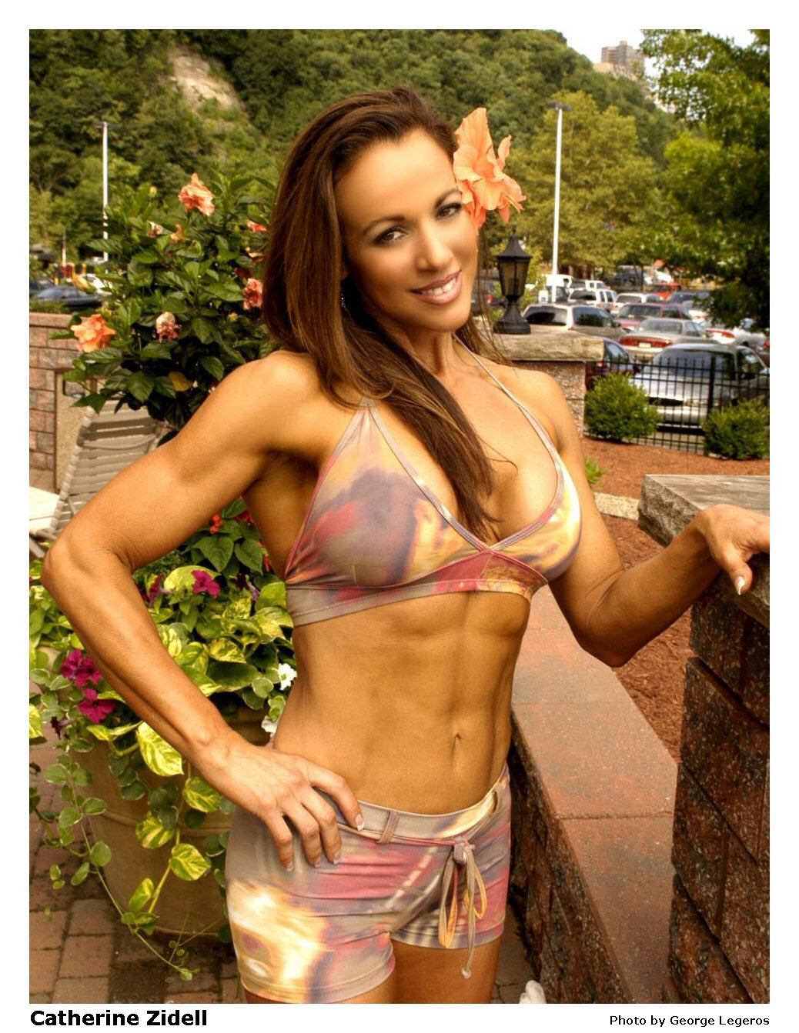
COMPETITION HISTORY
2004 Masters Teen and Collegiate National/ Pittsburg PA
First place, Tall Figure 35+
2003 Masters Teen and Collegiate Nationals/ Pittsburg PA
Fifth place, Tall Figure 35+
2003 Southwest USA/ Arlington,TX
Second place, Tall Figure
Third place, Masters Figure
2002 Texas State Championships/ Houston TX
Second place, Masters Figure
2002 Ronnie Coleman Classic/ Arlington TX
Third place, Tall Figure
2002 Lone Star Classic/ Plano TX
Second place, Masters Figure
2001 Tournament of Champions/ Culver City CA
Second place, Tall Figure
2001 Red River Classic/ Oklahoma City OK
Third place, Tall Figure
1999 Lackland Classic Bodybuilding/ San Antonio TX
First place, Women Open Heavyweight
1998 Ironman/ Culver City CA
Second place, Women Heavyweight
1998 Southwest Natural Bodybuilding/ Ft. Worth TX
Second place, Women Opend Heavyweight
1997 Lackland Classic Bodybuilding/ San Antonio TX
First place, Women Novice Heavyweight
1996 Ironman Natural/ San Antonio TX
Second place, Women Novice Heavyweight

